21st-Century Teaching and Learning:
Name of Author:
Institution:
Date:

Part 1: The Word Cloud: Characteristics of a 21st Century Learner, Student & Parent.

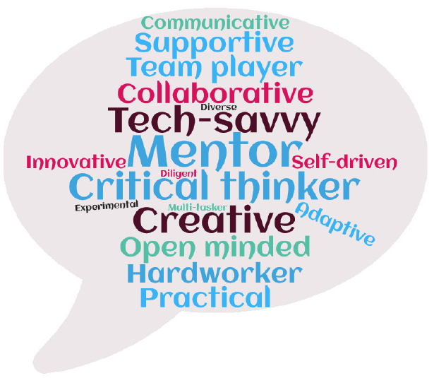

Part 2: My Personal 21st-Century Teaching and Learning Mission Statement
My mission as a teacher is to guide and elevate the position of learners in line with the set goals and objectives. I will be their mentor and support as they face the diverse classroom activities but also challenge them to be active learners for better skill acquisition and competency. In full recognition that technology has become a critical component in the 21st Century learning, I will avail and support the learners in the adoption of various technologies to maximize their learning. In my quest to impact knowledge to the young learners, I will fully integrate technology in the learning activities since today’s learners are generally techno-savvy, with competence in the use of computers, smartphones, tablets and other devices.
Additionally, in my mission as an educator, I recognize and support the efforts by national curriculum developers to integrate technology in learning. I firmly believe that state and national standards in learning should be reflective of the curriculum that is largely technology based. My mission is to support better educational standards by utilizing a wide pool of technological resources as enshrined in the curriculum. In my capacity as a teacher I recognize how technology has been integrated into learning through many fronts such as PowerPoint presentations, use of school tablets, game-based learning and online grading including custom software such as Listserv that promotes better communications with parents. As a teacher, I yearn to fully individualize learning so that every student gets adequate support and direction in the use class-based technologies to enhance learning.
Finally, in my mission to impact knowledge on the learners, I also recognize that technologies are forever evolving and I express my commitment to openly welcome new technological avenues to support classroom learning. Further on, I do acknowledge digital and media literacy as the ability to understand, and critically analyze media messages including use of social media and the internet. As a dedicated teacher, I will expand my limits in the digital and media literacy to be of better help to the learners. I will reach out and incorporate other media/techniques to develop the learning of the students. Bottom-line, I aspire to be a competent teacher who is dedicated to use technology just for instruction delivery but ensuring the learners grow and nurture their knowledge.

